Saturday Science: Spring 2017
Creatures of the Sea
Week 1

Mammals of the Sea
The ocean is full of all sorts of wondrous creatures, but how do we tell them apart? What’s a mammal and what’s a fish? What’s a pelagic or a benthic animal? How about the ones that spend part of their time on land (terrestrial)? Today we begin to go over characteristics of mammals and learn about just a few of the many that inhabit our ocean environment. Students will learn about mammals through the use of pictures, crafts, games, and dances.

Learning Objectives:
-Students will be able to understand what the characteristics of mammals are:
hair/fur at some point in their development, warm-blooded, give birth to live
young, and in terms of differentiating them with fish, they breathe through the use
of lungs.
-Blubber vs Fat? What about fur? Students will learn the different ways in which sea
mammals stay warm
-Students will know how to tell apart seals and sea lions
-Students will understand how different mammals catch their food and what
adaptations they use to do so.
-Students will understand that an animals morphological traits are clues that can tell
us about their lives.
-Students will be able to identify the different fin types on a dolphin

Vocabulary: Pelagic, benthic, dorsal (fin), ventral, pectoral fin, pelvic fin, caudal fin

Materials:
Items | Usage | Quantity
Crayons | Coloring Sheets
Styrofoam cups | Body of the whale(whale craft) | 30
Blue /gray paint | To paint the Styrofoam cups(whale craft)
Pipe cleaners | Blue/gray/white(whale craft) | ~100
Googly Eyes | (Whale craft) | ~50
Glue sticks/  elmers glue | (Whale craft & Otter craft) | ~10
Safety scissors | (Whale craft & Otter craft) | ~24
Blue/Grey  Card stock | (Whale craft) | ~30
Brown Construction Paper | (Otter craft) | ~30
Asst. Construction Paper | To make asst fish (Otter game) | ~20
Green Felt | To make kelp (Otter Game) | A few yards
Worksheets | A variety for students to color in (mammals)
Clear Protector Sheets | Vocabulary Match Game
Pictures | Vocabulary Match Game

Activities:
9:30-9:40: Welcome! All students will sit at a table with a worksheet to color in while everyone gets checked in (Dolphin coloring sheet).
9:40-9:50: Icebreaker: Each student will introduce themselves and say what their favorite sea creature is.
9:50- 10:00: Story time-We will read a book about mammals!
10:00-10: 15: What are mammals? We will begin by looking at pictures of mammals and then create a list of some mammal characteristics on the board. Walruses, sea lions, seals, otters, and dolphins will be our main focus.
10:15-10:25: Fin Dance! We will go over some new vocabulary words while dancing.
10:25-10:55: Whale Craft & Bathroom break! (Walrus coloring sheet available)
10:55-11:05: Snack break
11:10-11:20: Otters and Walruses-How do they keep warm?
Students will learn the difference between blubber and fur and which animal has the most hair per square inch in all of the animal kingdom.
11:20-11:30: Otter Craft
11:30-11:55: 3 stations (8 students each) 7 minutes per station
-1 Feed the baby otter
Students need to take their baby otter, wrap it up in the kelp, and go find fish to eat. Students then need to come back to their baby otter and unwrap it from the kelp.
-Picture vocabulary match
Students will hear and see their new vocabulary words and then try to match them with the correct picture.
-Seal vs. Sea lion
Students will run like a sea lion or a seal to get to their fish. The instructor will yell out ‘sea lion’ or ‘seal’ and the students will have to switch up pretending which one they are until they reach their fish.
11:55: Wind down & gather crafts/coloring sheets
12:00: Take home an otter coloring sheet!

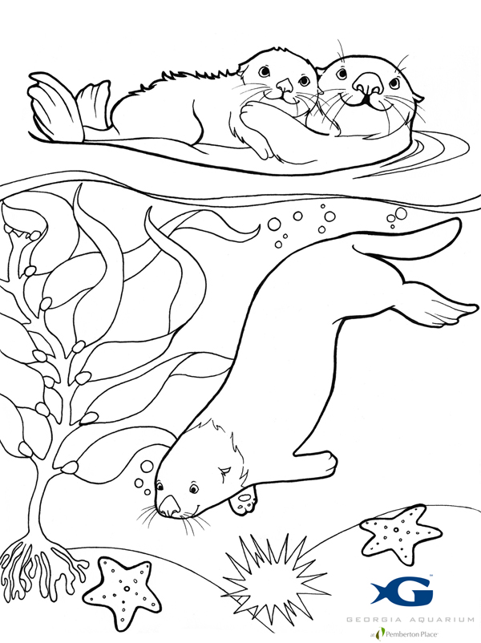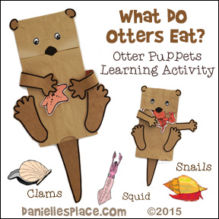
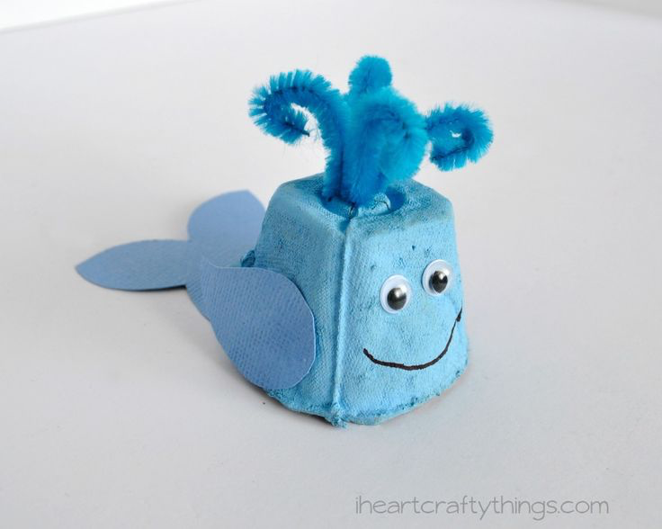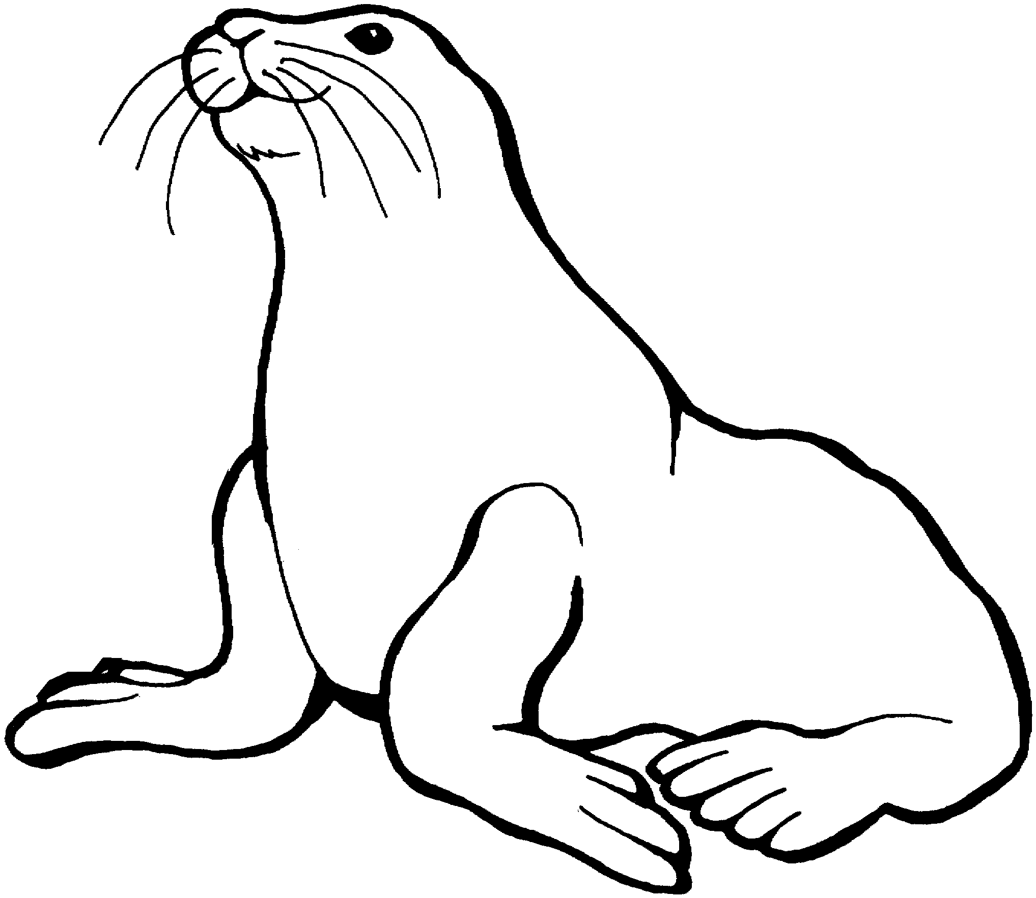

Saturday Science: Spring 2017
Creatures of the Sea
Week 2

Fish of the Sea
Fish! There are so many amazing types out there in the sea! Today we begin by learning about just a few of the many that inhabit our ocean environment and what role they play in the food chain (sharks will be covered on a different day). Students will learn about fish through the use of pictures, crafts, games, and dances.

Learning Objectives:
-Students will be able to understand that fish are EXTREMELY DIVERSE and come in
many different shapes and colors
-Students will learn that fish can inhabit all types of aquatic environments.
-Students will know that some fish have special relationships with other fish and/or
other sea creatures (mutualism)
-Students will learn what an important food source fish can be for certain animals
that live near or in the ocean.
-Students will know who the largest fish in the ocean is
-Students will know the feeding habits of certain fish
-Students will understand how important fish are to a healthy ecosystem

Vocabulary: lateral line, Fin review (dorsal, pectoral, pelvic, caudal), pelagic, benthic, diverse, mutualistic, gills, scales

Materials:
Items | Usage | Quantity
Crayons | Coloring Sheets & (Fish craft)
White paper dinner plates | (Fish craft) | ~50
Large Plastic Eggs | (Penguin Game) | ~12
White out | (Whale shark craft) | ~10
Googly Eyes | (Whale shark & Fish craft) | ~100
Glue sticks/  elmers glue | (Whale shark craft & Fish craft) | ~20
Safety scissors | (Whale shark craft & Fish craft) | ~24
White Oak Tag | (Whale shark craft) | ~13
Asst. Construction Paper | To make asst fish (Penguin game) | ~20
Streamers | To make a large Anemone(Clownfish Game) | A few yards
Worksheets | A variety for students to color in (Fish)
Clear Protector Sheets | Vocabulary Match Game
Pictures | Vocabulary Match Game
Asst. Glitter/Sequins | (Fish craft)
Popsicle Sticks | (Whale shark craft) | ~25

Activities:
9:30-9:40: Welcome! All students will sit at a table with a worksheet to color in while everyone gets checked in (Fish).
9:40-9:50: We will read a book about Fish!
9:50- 10:05: What are fish? Fin dance review, diversity
We will spend time looking at pictures of fish from different habitats to explore how diverse they are
10:05-10: 15: Mutualism and Anemone Game.
Students will all be given a nametag in the shape of a clownfish. The volunteers will each be a different color anemone, holding up their streamers to the students can see them. Each anemone will have five streamers that the students can hold on to (one student per streamer). When the instructor yells ‘go’ the students must run to an anemone and grab one of the streamers. If there are no streamers left, then that clownfish has been eaten by a predator and is out for the next round. As the number of students playing gets smaller, so do the amount of streamers that the anemone has. Each anemone will be left with just one streamer by the last round. The game will continue until there is only one clownfish left per anemone. If time permits, we will play this game twice.
10:15-10:25: Fish Craft
Students will make a paper plate fish
10:25-10:40: Snack break /Bathroom break! (Fish #2 coloring sheet available)
10:40-11:00: Whale Sharks, the biggest fish in the sea! What do they eat? Whale Shark Craft!
Students will learn about the characteristics of a whale shark. Students will then make their own whale shark to take home.
11:00-11:15: Penguin Game
Students will learn how fish are an important part of the diet of many animals that live in and around the sea. Students will balance a plastic penguin egg on their feet. Students must ‘waddle’ over to the other side of the room to give their egg to another penguin. Once the egg is dropped off, that student can go find fish for food. While one student is finding fish, their partner will try to make it back across the room with the egg balanced on their feet. This may be played for two rounds if time permits
11:15-11:25: Vocab Match
11:25-11:35: Fish sorting with Rainbow Goldfish!
Students will be given a handful of rainbow colored goldfish that they must sort into categories based on the color. Students will then graph their ‘fish’. Each table will compare their graphs.
11:35-11:55: Worksheet: fill in fish characteristics
Students will work together to fill out a worksheet of fish characteristics. We will then come together as a class and go over some of the characteristics we learned about fish today.
11:55: Wind down & gather your crafts/coloring sheets
12:00: Take home a penguin coloring sheet!

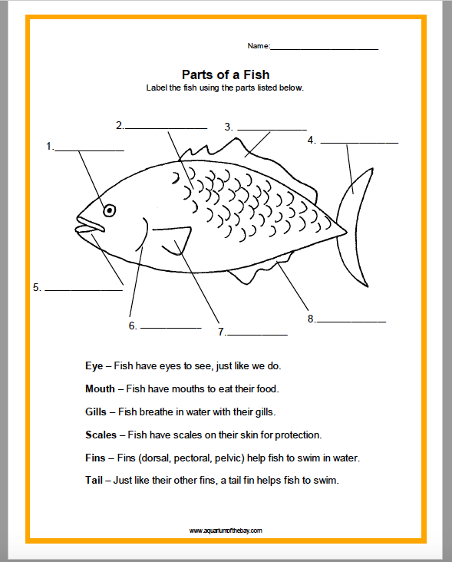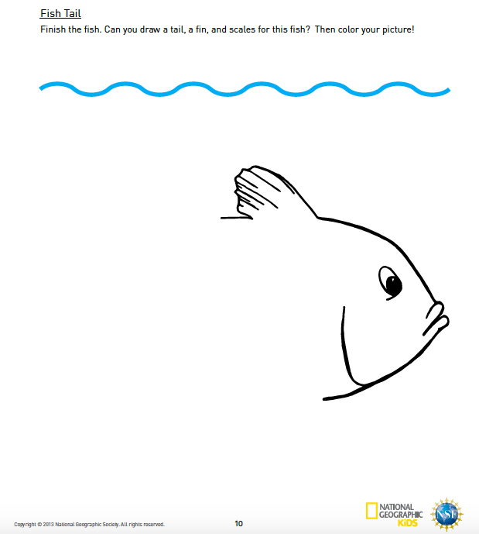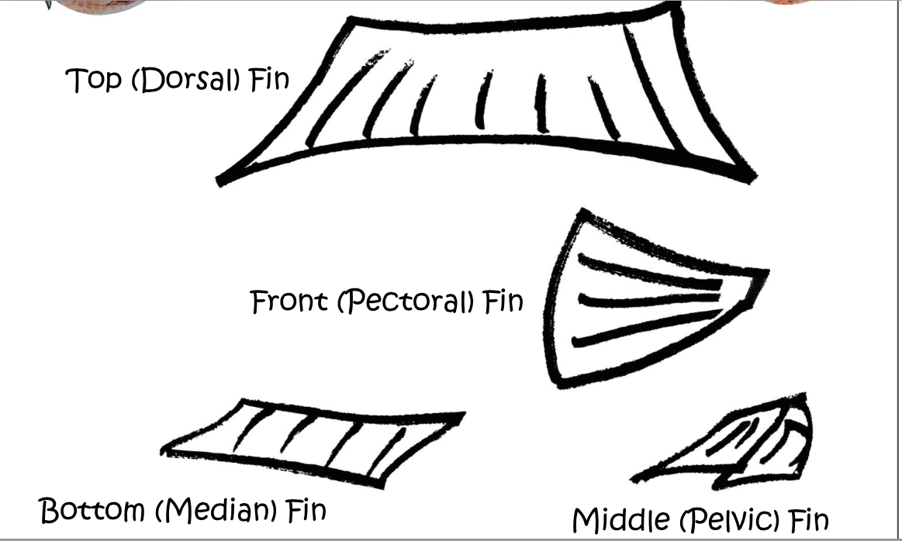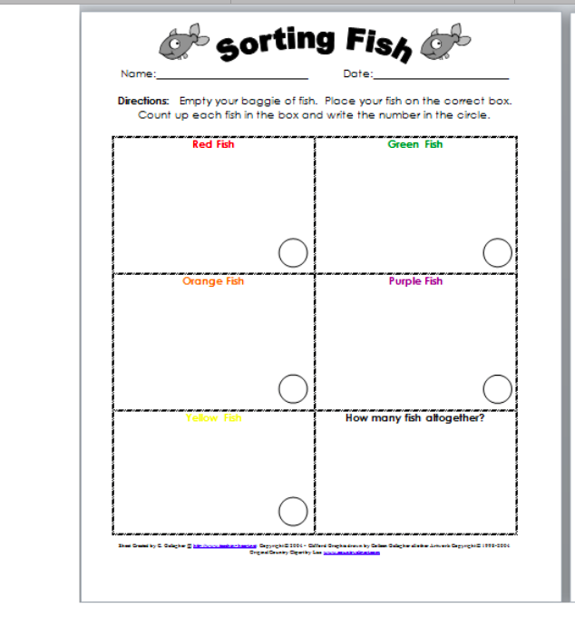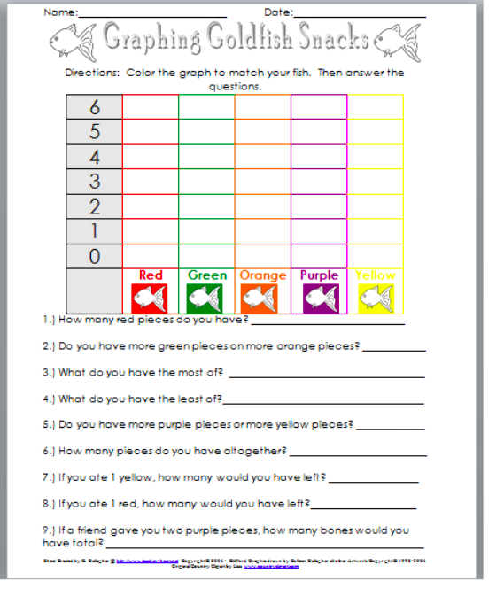

Saturday Science: Spring 2017
Creatures of the Sea
Week 3

Sharks & Sea Jellies
Sharks just look mean. Today we will learn all about sharks and the important role they play in the ecosystem. We’ll spend time going over teeth, body shape, how their scales are different than those we saw last week in fish, the diversity amongst sharks, and learn about their cartilaginous skeleton. Its all about flexibility and speed for these amazing hunters.
We’ll also spend time learning about sea jellies (not jelly fish!). We’ll talk about some of the different types that are found in the ocean along with how they eat, how they sting, and what type of skeleton they have. Don’t ever touch a sea jelly on the beach!

Learning Objectives:
-Students will be able to understand that sharks and sea jellies are DIVERSE!
-Students will learn that sharks have a cartilaginous skeleton
-Students will learn that sharks have rows of teeth that regenerate throughout their
lifetime
-Students will learn that we are not the preferred food for a shark and why
-Students will understand the role that sharks play in keeping an ecosystem healthy
-Students will know that it is dangerous to touch a dead sea jelly on the beach
-Students will understand how sea jellies sting
-Students will learn who eats sea jellies and how important they are to our oceans

Vocabulary: Countershading & fin review (dorsal, pectoral, pelvic, caudal), cartilage, sea jelly, dermal denticles (skin teeth)

Materials:
Items | Usage | Quantity
Crayons | Coloring Sheets & (Sea Jelly craft)
Chalk:  mutlicolored | Shark drawings
Tape Measure | Shark Drawings | 6
Streamers:  multicolored | (Sea Jelly craft)
Googly Eyes | (Sea Jelly craft) | ~50
Glue sticks/  elmers glue | (Sea Jelly craft) | ~20
Safety scissors | (Whale shark craft & Fish craft) | ~24
Paper plates | (Sea Jelly craft) | ~25
Asst. Construction Paper | Sea Jelly craft & Bingo tokens | ~20
Clear Protector Sheets | Vocabulary Match Game
Pictures | Vocabulary Match Game
Sand | Enough to fill 6 plastic bins
Plastic Bins | 6
Clay | Shark Teeth | 2 lbs

Activities:

9:30-9:35: Welcome! All students will sit at a table with a worksheet to color in while everyone gets checked in (Shark).
9:35-9:45: Lets review mammals!
9:45- 9:50: We will read a book about Sharks!
9:50-10:05: What are sharks? Diversity? How are they different from other fish? Cartilage dance! Teeth?
10:05-10:15: Shark Bingo
Each student will receive a bingo card with several different sharks listed and tokens. The instructor will pull sharks out of a bag until one of the students yells BINGO. If time allows, we will play two rounds
10:15-10:20: Get in teams to draw life size sharks.
Each team will receive a tape measure and chalk. One team member will pull the name of a shark out of a hat; this is the shark the team will draw outside. Each team will be provided with two pictures of their shark and the measurements.
10:20-10:45: Outside to draw sharks!
10:45-11:05: Snack break /Bathroom break! (Shark #2 coloring sheet available) Watch Shark Video. Clean up time!
11:05-11:25: Be a keeper! Find all the shark teeth!
Each table will receive a bin full of sand (with buried clay shark teeth), and a sifter. Each student will get a turn ‘being a keeper’ and cleaning up the all of the shark teeth. Students will get to sift once, collect the teeth and then pass the sifter on to the next student. This will be done until all of the students have at least 2 teeth but we may keep going until the bin has no teeth left.
11:25-11:40: Read Sea Jelly book/Learn about Sea Jellys!
11:40-11:55: Sea Jelly Craft
11:55-12:00: Wind down & gather your crafts/coloring sheets
12:00: Take home a Sea Jelly coloring sheet!
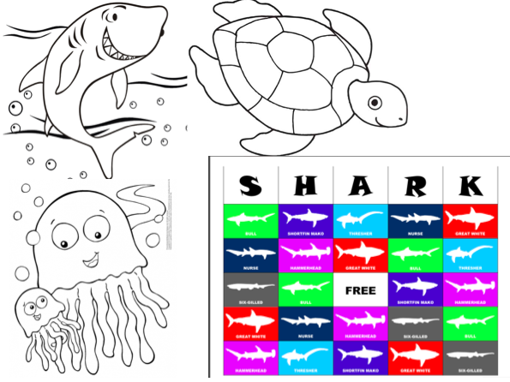

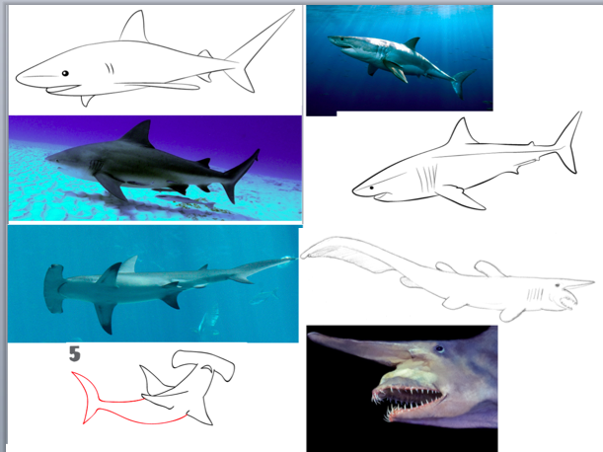

Saturday Science: Spring 2017
Creatures of the Sea
Week 4

Deep Sea Day!
While exploring a marine habitat, the deep sea, students’ will not only learn about the animals that live there but also which adaptations are especially beneficial for that specific habitat. This knowledge can then be used to compare against other animals that inhabit different ecosystems. Through the following lesson, Students will be able to describe characteristics and coloration patterns of deep-sea animals as well as developing a basic knowledge of the light spectrum through hands on activities, observations, and collaboration.

Learning Objectives:
-Students will learn about the characteristics that enable animals to survive in the
deep sea
-Students will learn what role color plays in deep sea survival
-Students will know that some fish exhibit bioluminescence
-Students will learn about ballast and submarines
-Students will learn squid characteristics
-Students will understand which colors penetrate to the deepest depths of the ocean

Vocabulary: light spectrum, bioluminescence, ballast

Materials:
Items | Usage | Quantity
Crayons | Coloring Sheets
White paper | Paper glasses | ~24
Blue saran wrap | Paper Glasses | 1 roll
Black construction paper | Light spectrum activity | ~6
2L Soda bottles | Submarine activity | ~6
Plastic Bins | Submarine activity | ~6
Safety scissors | Squid activity | ~24
washers | Submarine activity | ~50
Asst. Construction Paper | Light spectrum activity/Squid activity | ~20
Streamers | Squid activity | A few yards
Worksheets | A variety for students to color in (of todays animals)
Balloons | Squid Activity | ~10
Tape | Squid activity | ~6 rolls
Dixie cups | Submarine activity | ~10
Popsicle Sticks | Lantern Fish activity | ~24
Glow in the dark paint | Lantern Fish Activity
Toilet paper rolls | Squid craft | ~24
Yarn | Squid craft | 1 spool
Googly eyes | Squid craft | ~50

Activities:

9:30-9:35: Welcome! All students will sit at a table with a worksheet to color in while everyone gets checked in (angler fish).
9:35-9:45: Shark/Sea Jelly Review
9:45- 9:50: We will read a book about creatures of the deep!
9:50-10:05: Who lives way down in the ocean? What color are they? Why do they look so ‘scary’? How does light travel to the ocean? How do we find these animals?
10:05-10:15: Sea glasses!
Students will take paper glasses with blue lenses and look at a variety of different colors. The students will then get another, darker blue lens to hold in front of their glasses to look at the colors again. Students will see that as the blue gets darker, certain colors are harder to see while certain colors are easier.
10:15-10:30: Submarine Activity
Students will work in teams to balance their ‘submarine’. Students will have a paper cup that they need to make float in the middle of a 2L soda bottle full of water. Students will have ballast (washers) that they can attach and take off of the cup in order to cause the ‘submarine’ to float in the correct position.
10:30-10:40: Color in ‘dive in the deep’
10:40-10:50: Snack break /Bathroom break! (coloring sheet #2available) Watch video. Clean up time!
10:50-11:05: Squid Book! Learn all about squids!
11:05-11:30: Squid Races
Students will design a balloon squid that they will then race across the room by letting the air out.
11:30-11:40: Make your own mini squid
11:40-11:55: Lantern fish craft
11:55-12:00: Wind down & gather your crafts/coloring sheets
12:00: Take home a squid coloring sheet!
https://www.montereybayaquarium.org/education/classroom-resources/curriculum/exhibit#mission-to-the-deep

http://www.pbs.org/wgbh/nova/education/activities/3319_alicia.html

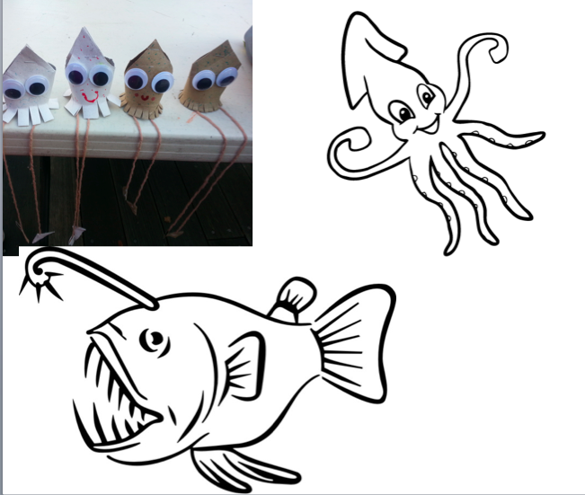

Saturday Science: Spring 2017
Creatures of the Sea
Week 5

Arthropods!
Learning Objectives:
-Students will be able to understand how diverse arthropods are
-Students will learn about one of the greatest migrations (Christmas Island Crab)
-Students will understand that arthropods have their skeleton on the outside
-Students will know how certain crabs protect themselves
-Students will learn that hermit crabs need to find new shells as they grow
-Students will learn that horseshoe crabs are not dangerous and may need our help sometimes

Vocabulary: exoskeleton, molting

Materials:
Items | Usage | Quantity
Crayons | Coloring Sheets & Final Project
Asst tissue paper, tinfoil, feathers, cotton balls | Decorator crab activity | ~100  pieces total
Glue sticks/  elmers glue | Final Project | ~20
Safety scissors | Final Project | ~24
Asst. Construction Paper | Final Project | ~20
Streamers | Final Project | A few yards
Worksheets | A variety for students to color in (of todays animals)

Activities:

9:30-9:35: Welcome! All students will sit at a table with a worksheet to color in while everyone gets checked in (hermit crab).
9:35-9:45: Lets review the deep sea!
9:45- 9:50: We will read a book about the ocean-Wow! Ocean!
9:50-10:00: Who are the arthropods? Where are their skeletons?
10:00-10:15: Lets make a decorator crab
Students will have an outline of a crab. The instructor and volunteer will go to each table with a shoebox full of items for the students to decorate their crabs with in order to camouflage their crab. Students will be asked to close their eyes and then they may reach into the box and take a few items to use. The instructor and volunteers will keep allowing students to take turns ‘finding’ material to camouflage with until the shoeboxes are empty.
10:15-10:25: Which Shell will fit?
Students will be given a cut out of a hermit crab with no shell. A pile of paper shells will be put in the middle of the table. Each student must try out the different shells until they find the one that fits their hermit crab.
10:25-10:45: Food Chain Group Work/Make a food web
10:45-11:00: Snack break /Bathroom break! (Horseshoe crab coloring sheet available) Clean up time! Magic School Bus
11:00-11:15: Lets Review (iPad activity)
11:15-11:25: Marine science careers (draw yourself in one!)
11:25-11:55: Our Final project
Students will close their eyes and imagine they are swimming through the sea. What do they see? Whatever they see they will draw along with their favorite sea creatures as their final craft.
Game if we have time.
11:55-12:00: Wind down & gather your crafts/coloring sheets

